1. The Pendulum Inverted on a Cart.

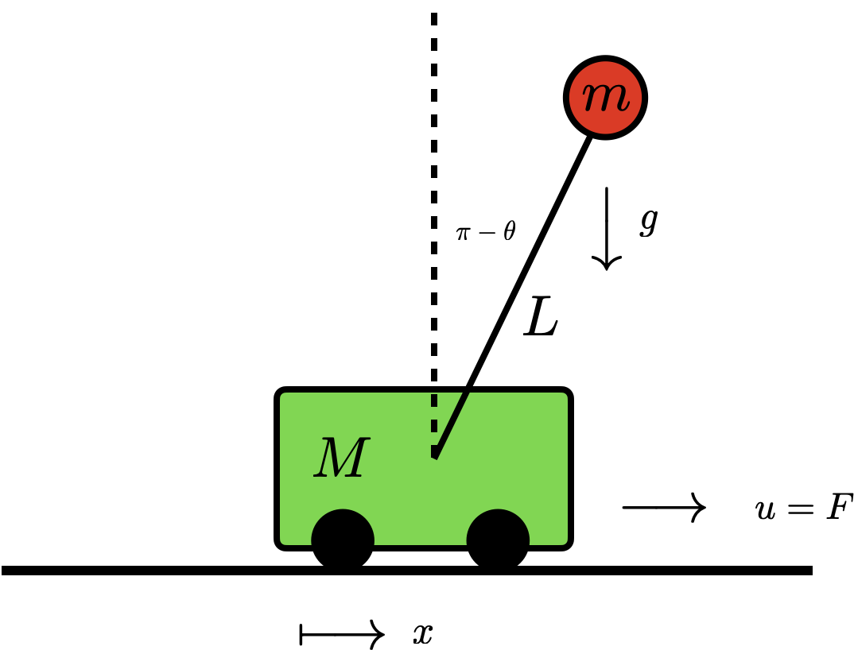

Figure 1. Schematic of inverted pendulum on a cart. The control forcing acts to accelerate or decelerate cart.

* + - Derive the equations of motion of the system.
    - Simulate the control free response of the system using various initial conditions.
  1. Proposed control techniques:
     + PID
     + LQR
     + MPC
     + PID with Genetic Algorithm (gain tuning)
  2. <https://digitalrepository.unm.edu/cgi/viewcontent.cgi?article=1131&context=math_etds#:~:text=1.2%20System-,The%20Double%20Pendulum%20Inverted%20on%20a%20Cart%20(DPIC)%20system%20is,horizontally%20and%20manipulate%20the%20system>.
  3. <https://apmonitor.com/do/index.php/Main/DoubleInvertedPendulum>

1. Stabilization of the reaction wheel pendulum
   1. Place holder
   2. <https://ieeexplore.ieee.org/document/7076312>
2. Autonomous Vehicles: Lateral Control for the Car’s Bicycle Model
   1. <https://archit-rstg.medium.com/two-to-four-bicycle-model-for-car-898063e87074>
   2. <https://archit-rstg.medium.com/two-to-four-bicycle-model-for-car-898063e87074>
3. Nonholonomic Mobile Robots
   1. A mobile robot that is subject to nonholonomic restrictions is referred to as nonholonomic. Nonholonomic restrictions are limitations on the robot's speed; they do not condense the space of possible configurations.
   2. Nonholonomic constraints can be exemplified by:
      * A car cannot veer off the road while it is moving forward.
      * A unicycle is completely immobile in the side.
      * A robot with differential drive cannot immediately rotate.
   3. Robots that are subject to nonholonomic constraints, known as nonholonomic mobile robots, are harder to control than holonomic mobile robots. This is because the robot's mobility may be constrained by nonholonomic constraints.
   4. Proposed Control Schemes:
      * MPC
      * PID
      * LQR
      * Comparison between all of them
   5. Model:

